English workshop

Name: Grade: Date:

I fill in the blanks using a suitable word. Use the words in the box below.

The Tortoise and the Hare
One of Aesop's Fables
Illustrated by Arthur Rackham
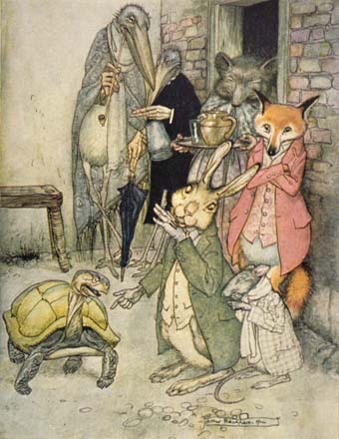
____ upon a time there was a hare who, boasting how he could run ______ than anyone else, was forever teasing tortoise for its slowness. Then one ____, the irate tortoise answered back: "Who do you think you are? There's no denying you're swift, ___ even you can be beaten!" The hare squealed with laughter.
"Beaten in a race? By whom? Not you, surely! I bet _______ nobody in the world that can win against me, I'm so speedy. Now, why don't you try?"
Annoyed by such bragging, the tortoise ________ the challenge. A course was planned, and the ____ day at dawn they stood at the starting line. The hare yawned sleepily as the meek tortoise trudged slowly off. When the hare saw how painfully slow his rival was, he _______, half asleep on his feet, to have a quick nap. "Take your time!" he said. "I'll have forty winks and catch up with you in a minute."
The hare woke with a start from a fitful sleep and gazed round, looking for the ________. But the creature was only a short distance away, having barely covered a third of the course. Breathing a sigh of relief, the hare decided he might as well have breakfast ___, and off he went to munch some cabbages he had noticed in a nearby field. But the heavy meal and the hot sun made his eyelids droop. With a careless glance at the tortoise, now halfway along the course, he decided to have _______ snooze before flashing past the winning post. And smiling at the thought of the look on the tortoise's face when it saw the hare speed by, he fell fast asleep and was soon snoring happily. ___ sun started to sink, below the horizon, and the tortoise, who had been plodding towards the winning post since morning, was scarcely a yard from the finish. At that very _____, the hare woke with a jolt. He could see the tortoise a speck in the distance and away he dashed. He leapt and bounded at a great rate, his tongue lolling, and gasping for breath. ____ a little more and he'd be first at the finish. But the hare's last leap was just too late, for the tortoise had beaten him to the winning post. Poor ____! Tired and in disgrace, he slumped down beside the tortoise who was silently smiling at him.
"Slowly does it every time!" he ____.
decided hare accepted said faster

The tortoise Once another point

there's faster Just next too

but day

